

Department of Electrical & Computer Engineering

North South University

**Test Plan**

Project Name: Burger Wagon

Submitted by: Team12

Abdullah All Noman Abir (ID: 1521047042)

Mohammed Taufiqur Rahman (ID: 1521285042)

GitHub Link: <https://github.com/nsuspring2019cse427/Group12>

Course: CSE427 (Software Quality Assurance & Testing)

Section: 01

Semester: Spring 2019

Submitted to: Shaikh Shawon Arefin Shimon (SAS3)

**Introduction**

Burger Wagon is your number one favorite online restaurant serving burgers. In this project we built and tested a REST backend that allows users to view the food menu online. For testing purpose, we followed the Test-Driven Development (TDD) method. Which means we wrote a test first and then wrote the corresponding function to pass that test which would have failed at first and eventually refactor.

**Testing Aspects We Implemented**

We have successfully implemented following tasks as testing aspects:

1. Unit testing each API functions.

2. Input space partitioning.

3. Graph partitioning.

4. Integration testing.

5. Functionality testing.

6. 100% test coverage

**Requirements**

1. Python 3.7

2. Flask micro framework

**Tools/Frameworks Used:**

1. Pycharm for writing code

2. Default Python unit test module

3. Postman and Insomnia for API testing.

**Input Space Partitioning:**

**Input variables used in this project are:**

- Id (integer).

- Title (String)

- Description (String)

- Price (float)

- Date created (function generated/ date-time)

**According to characteristics Input Space Partitioning:**

|  |  |  |  |
| --- | --- | --- | --- |
| **Characteristics** | **Block 1** | **Block 2** | **Block 3** |
| **String** | **Alphabetic value** | **Numerical value** | **null** |
| **Float** | **<1.0** | **>=1.0** | **Invalid float type** |

**Sample values:**

|  |  |  |  |
| --- | --- | --- | --- |
| **Characteristics** | **Block 1** | **Block 2** | **Block 3** |
| **String** | **“**Apple burger**”,** "pet kharap hobe na 50%" | **“**57983479**”** | **null** |
| **Float** | **0, -10.1** | **25 , 1200.00** | "APPLE" |

In the given github link -<https://github.com/nsuspring2019cse427/Group12>, under tests directory in these following files- **test_put_input_space_partitions.py** and **test_post_input_space_partitions.py; input space partitioning codes are available in the given criterion.**

**Graph Partitioning:** For graph partitioning we followed the edge coverage criteria. Firstly, we created graphs for all the API functions-get, post, put, delete and wrote the test requirements for covering edges. Then based on the test requirements we decided the test paths to be covered. After that we updated the existing unit test functions with graph partitioning and then wrote unit tests for the test paths which weren’t covered before graph partitioning. In the given github link -<https://github.com/nsuspring2019cse427/Group12>, under tests directory with every unit test graph partitioning is documented using comments.

**The corresponding graphs with test requirements and test path:**

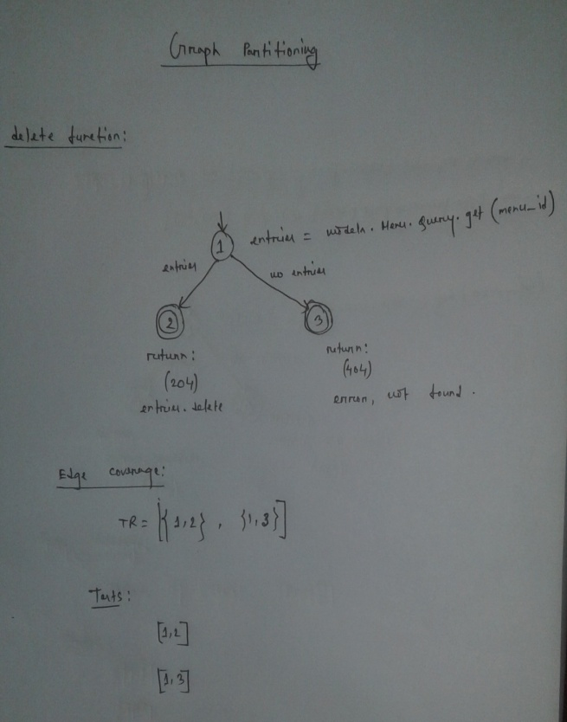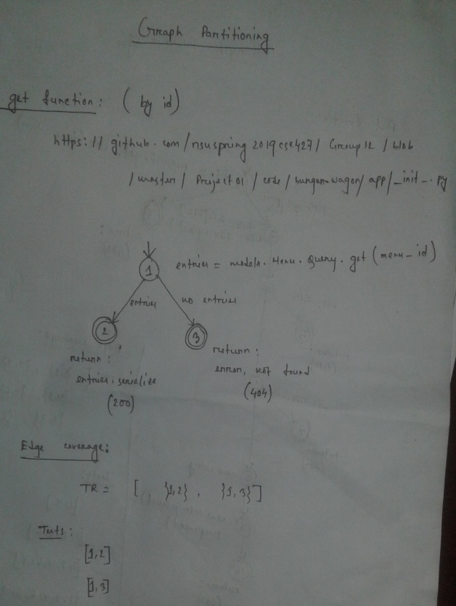

**Delete function graph Get function(by id) graph**

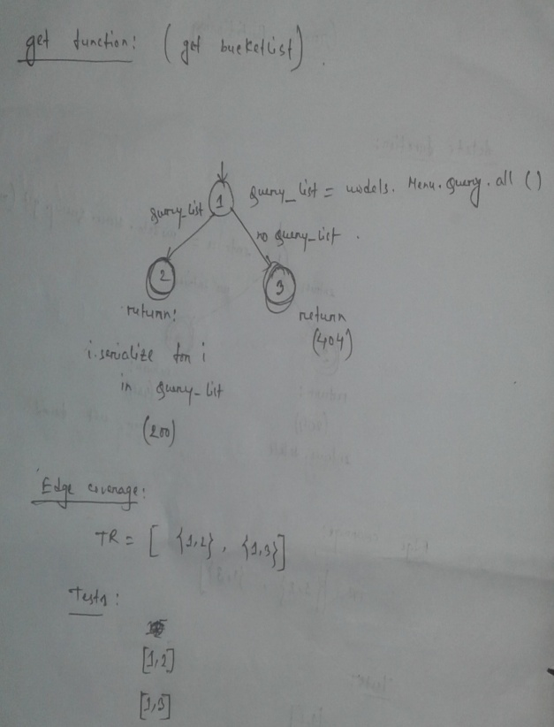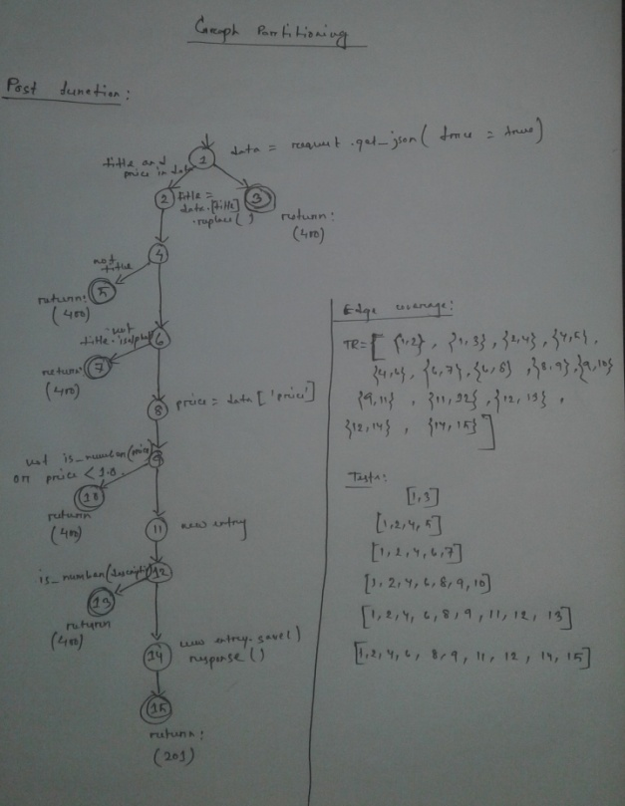

**Get function(for getting list) graph** **Post function graph**

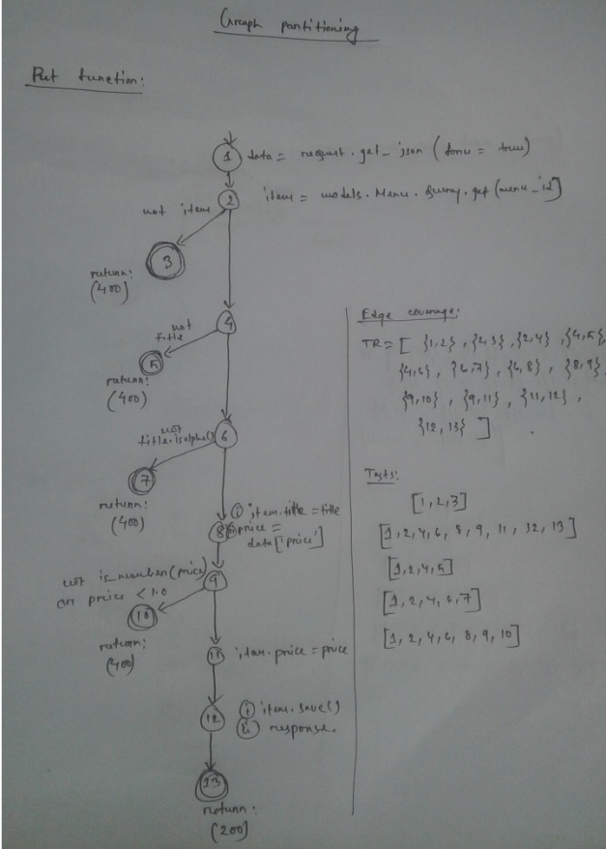

**Put function graph**

**Integration Test:** When we initially designed and wrote unit tests, we already did cover integration testing. For example: to test delete function we had to first post inputs, then delete it and after that, we had to use call get function to check whether the item got deleted. That means in a single unit test function we had to use these three API functions to test which is basically integration testing. For all other unit tests we wrote also comes under this rule.

**Functional Test:** For functional testing, we tested these following tests:

a. Smoke test.

b. Unit test.

c. Integration test.